Big Mountain Resort – Pricing Reorganization Report

Problem:

Big Mountain Resort has just purchased a new ski-lift, increasing their operating costs by $1,540,000. What type of logistical reorganization will be required for Big Mountain Resort to justify an increase in ticket price, specifically by examining data from comparable resorts, to remain profitable despite an increase in operating costs?

Summary:

Based on our research on ticket price and resort features customers care most about, we believe that the Big Mountain Resort can increase its adult weekend price from $81 to ~$95 without overcharging our customers. We are assuming that over 350,000 people will Big Mountain Resort this year, with most of them coming towards the weekend and staying on average of 5 days. This increase in price will help offset the costs associated with the new lift.

Analysis:

Our analysis involves using a linear regression model and cluster analysis to compare Big Mountain Resort against other 331 ski resorts in the US. The comparison includes ticket prices, maximum of runs, total skiable area, and many more. From a top-down perspective, when comparing to other resorts, Big Mountain Resort is a high elevation resort, and the highest in Montana (its most immediate market). It is priced fairly versus resorts nationally. Also, it has a top 3 highest vertical drop out of all the resorts in this analysis. Moreover, the resort leads the competition in both areas covered by snow and skiable terrain. These features help Big Mountain stand out against other resorts in the market, even at a higher price point.

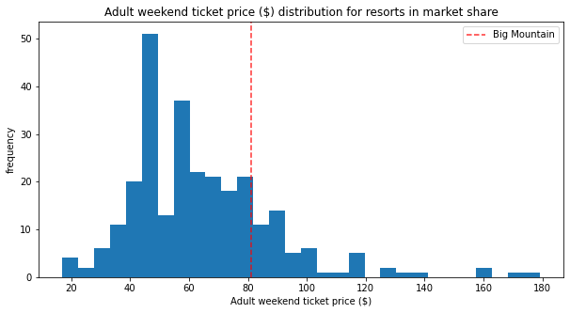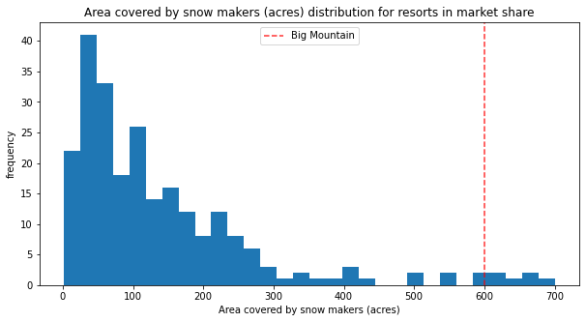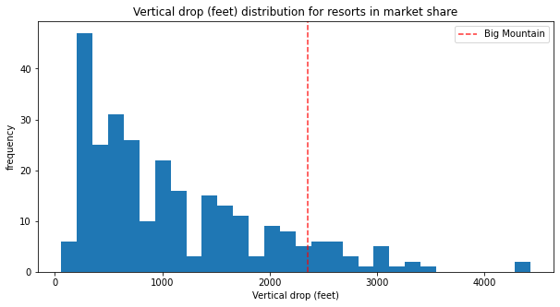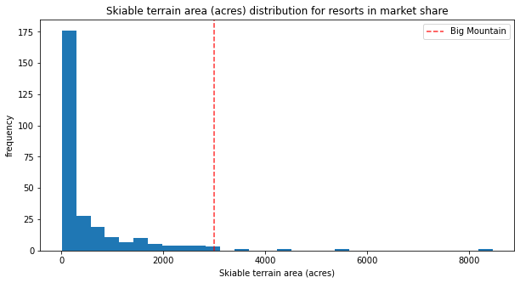

Regarding logistical reorganization, it may be acceptable for the resort to close any 1 of its least used runs, as we predict no difference in revenue.

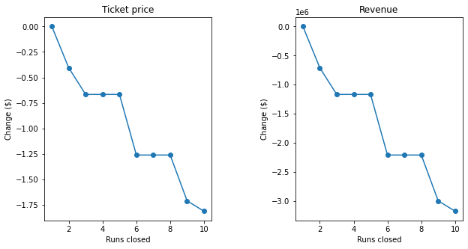

In terms of ticket price analysis, we found out that two of the most influential factors that affect ticket prices are the number of Quad-Seat Chairs and the number of Runs the resort can handle. The next two most influential factors are the vertical drop and the snow-making area. Big Mountain is the clear leader in the local market for these features and stands out in the national market. Nonetheless, our tickets are still competitively priced nationally.

In addition to potentially closing an unused run, adding a new run, increasing the vertical drop by 150 feet, installing an additional lift, and adding 2 more acres of snowmaking area can also justify an increase in ticket price by $8-9. These changes represent prime features that visitors would be willing to pay for, despite the resort being the most premium in Montana. Per mean error analysis, the minimum we could increase the ticket price would be $2.83. Depending on the extent of our structural changes, we could adjust that increase to be anywhere between $8.61 and $9.90.

Therefore, we can conclude that it is acceptable for the Big Mountain Resort to increase its Weekend ticket price from $81 last season to anywhere from $84 to $95 while remaining financially competitive.

